Tab 1

Module Name: Login Page
Test Case ID: 6
Webpage URL: https://practicetestautomation.com/practice-test-login/

- Scenario ID: 1
Scenario:Sign up with valid credential( ID/PASSWORD)
Test Steps:
1:Open Login Page
2:Enter Username
3:Enter A Password
4:Click on login button

Screenshots:
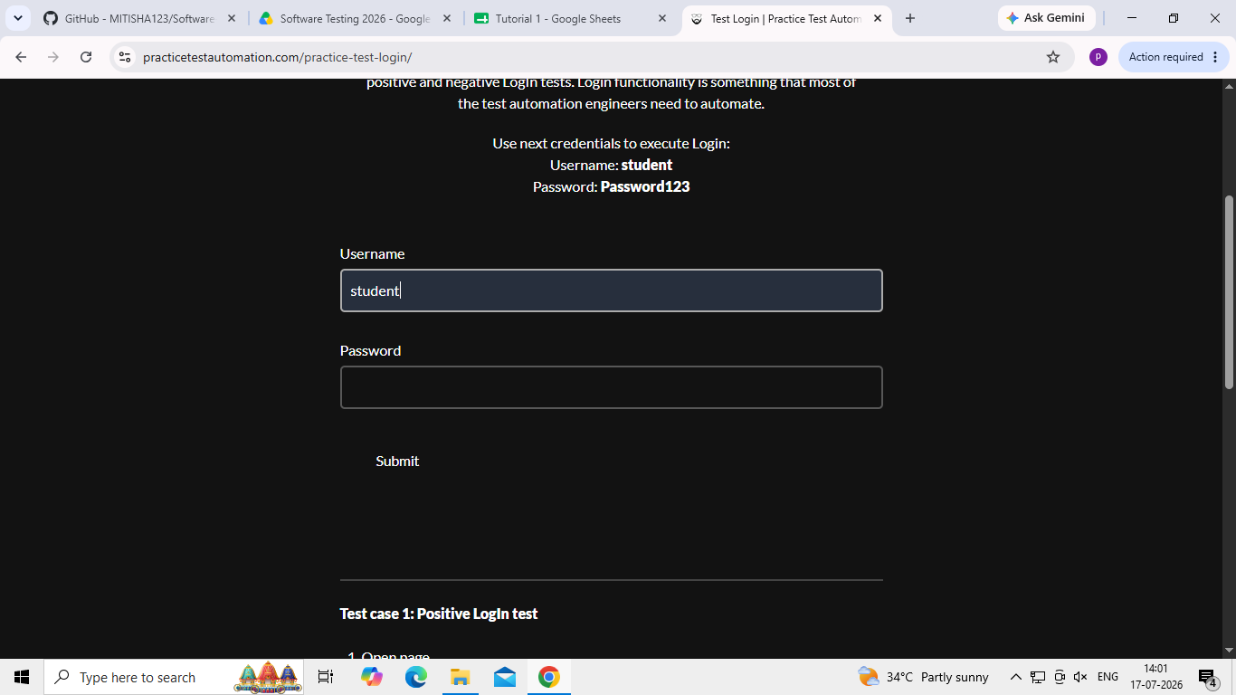
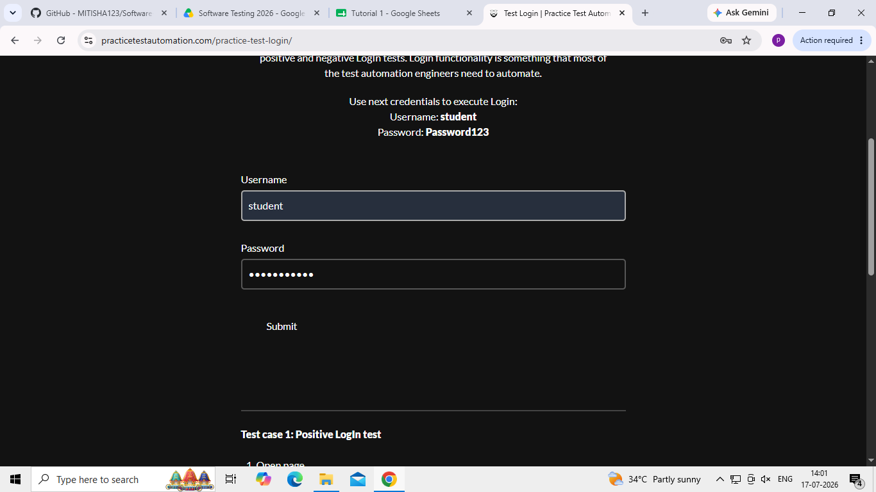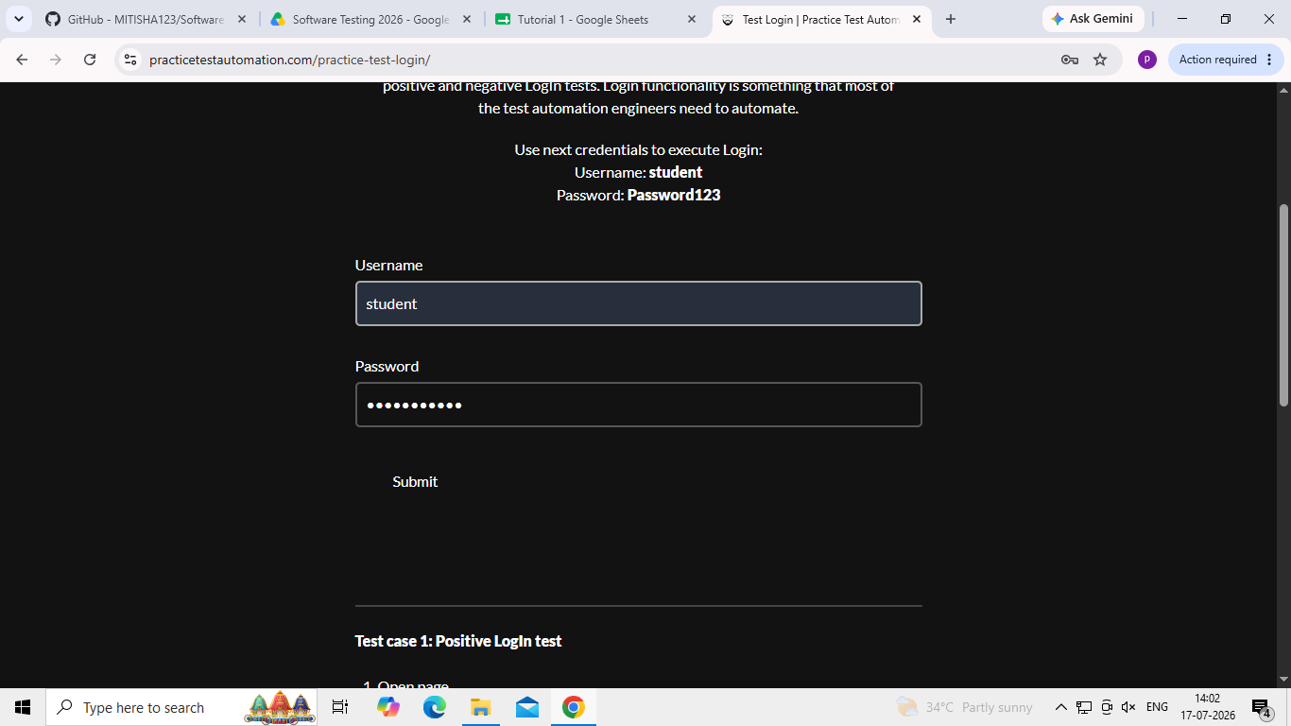

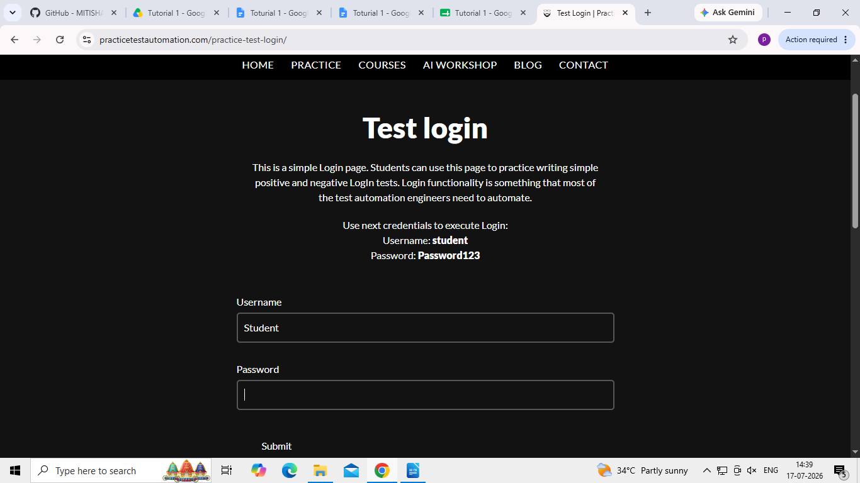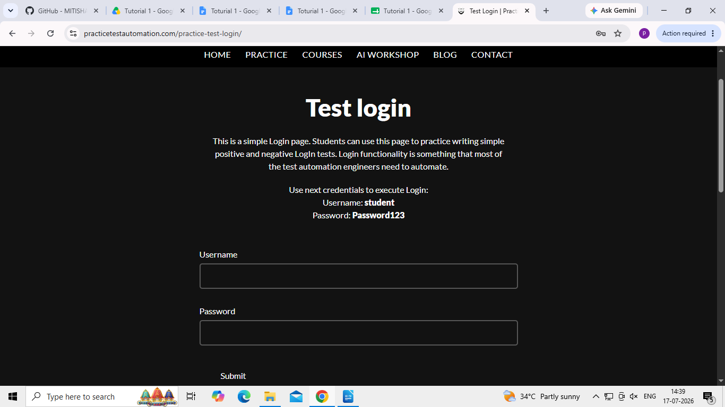

Scenario ID: 2
Scenario:Sign up with invalid credential( ID/PASSWORD)
Test Steps:
1:Open Login Page
2:Enter Wrong Username
3:Enter A Wrong Password
4:Click on login button

Screenshots:
